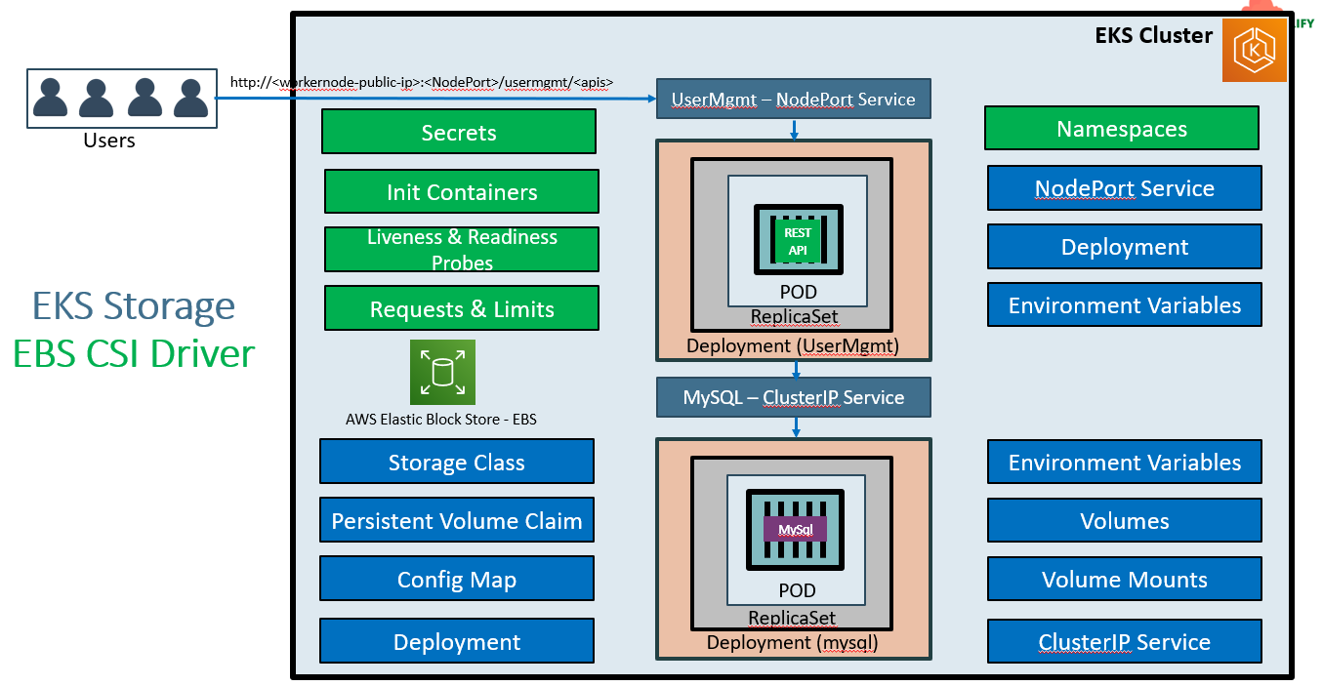
Secrets:-
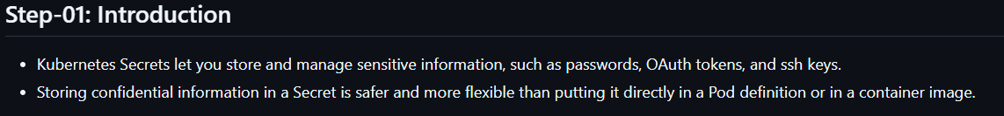
To encode passwords we can do it in 2 ways
Eg1 :
echo -n 'dbpassword11' | base64
Eg2:-
Open this link URL: https://www.base64encode.org enter your password and click on ‘encode’ then collect the encrypted password.
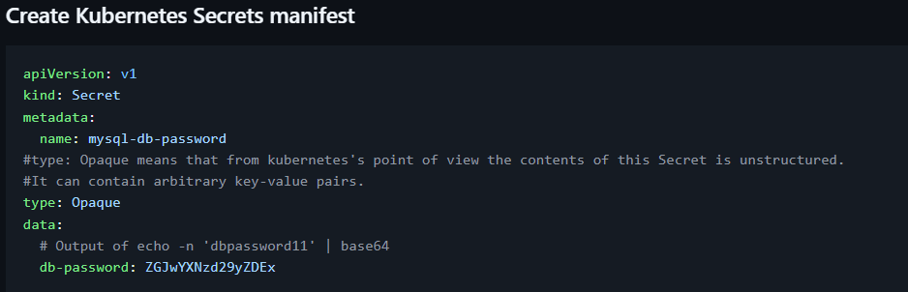
Now update the values
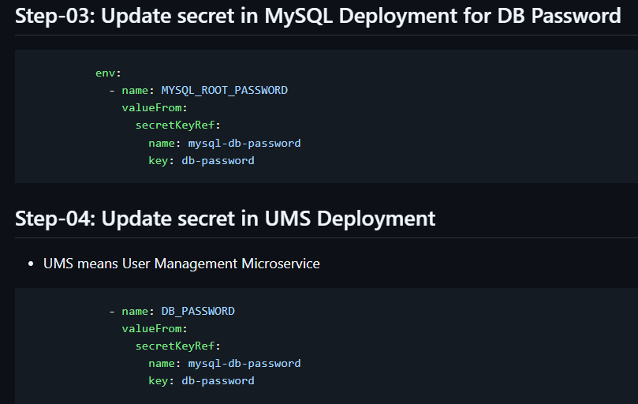
We have removed ‘value: dbpassword11’ and updated the values like above. Under ‘secretKeyRef’ the name and key values we will get it from secrets file which we have created above.
For this execution visit this aws-eks-kubernetes-masterclass/05-Kubernetes-Important-Concepts-for-Application-Deployments/05-01-Kubernetes-Secrets at master · stacksimplify/aws-eks-kubernetes-masterclass .

Note:- Still we got the POD restart issue for usermanagement service. We are going to see it in ‘init containers session’.
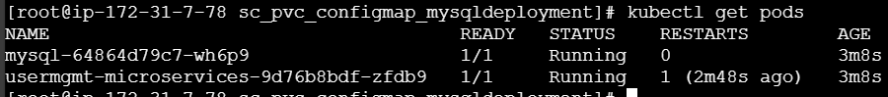
Kubernetes init Containers:
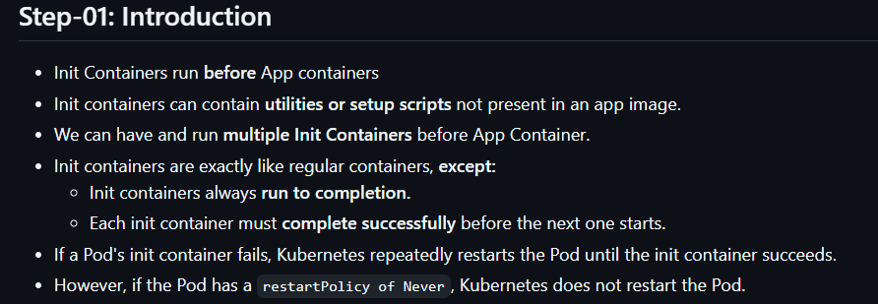
Eg: In previous session we have observed the restart issue. When an app trying to communicate with another service that user management service with mysql db. Until mysql db gets up the usermanagement will try to communicate with mysql and gets fail. During this process usermanagent service get restart. To avoid this we will implement ‘init containers’. When we define this whenever the mysql gets up then only the usermanagement service will start communicate. In this process a container will run before App container (usermanagement service).
Implementation:-
Define init containers like below
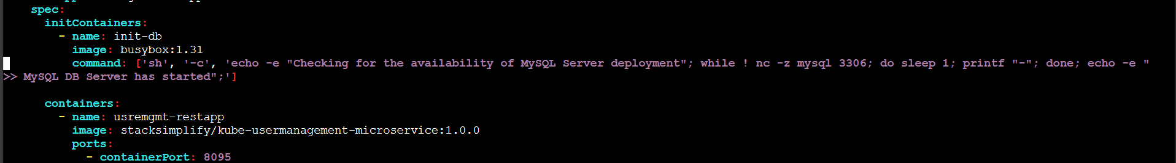
Above the ‘containers’ field we need to define the ‘initContainers’. Here we are using busy box.
After executing the scripts. You can watch the PODS
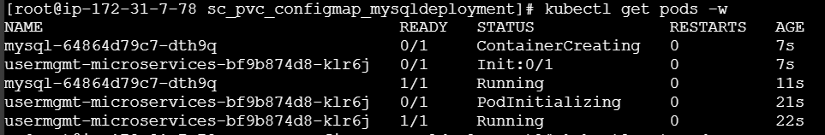
If you see it’s showing ‘Init:0/1’.
Now you can’t see the ‘restarts as 1’
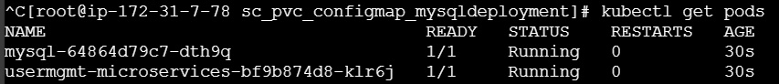
You can see the process in describe pod.
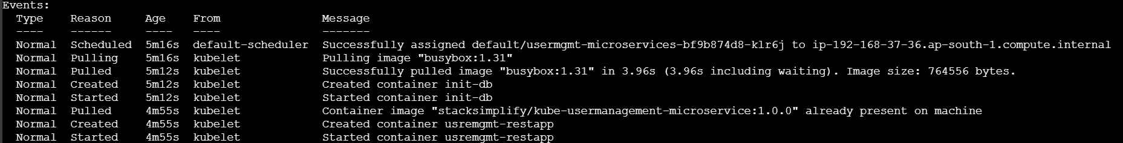
First it’s pulling busy-box then starting the init-db (init container) and then starting our usermgmt-service app.
To learn more about init containers read this K8s doc Init Containers | Kubernetes .

Kubernetes - Liveness & Readiness Probes:-
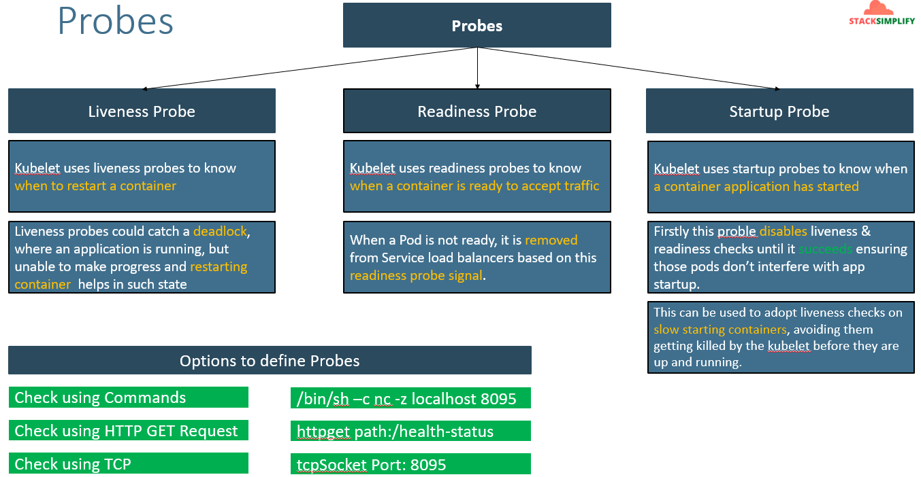
We are going to define the values liveness and readiness probe like below in our script.
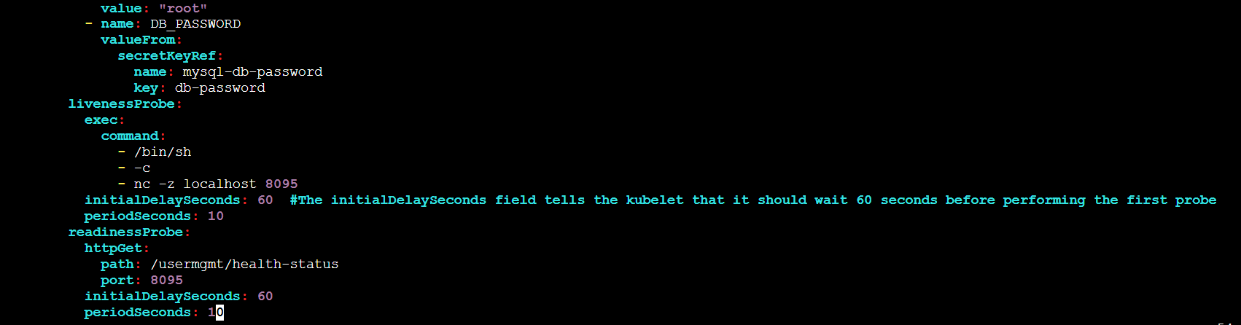
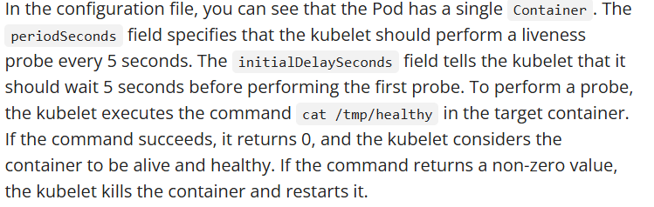
If you execute the script and watch the pods
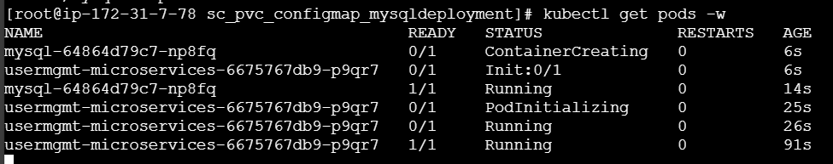
The usermgmt service took 91 secs to confirm that the service is running because of the probes we have configured that is 60+10 secs.
More to learn about the probes check here Configure Liveness, Readiness and Startup Probes | Kubernetes .

Requests and Limits:-
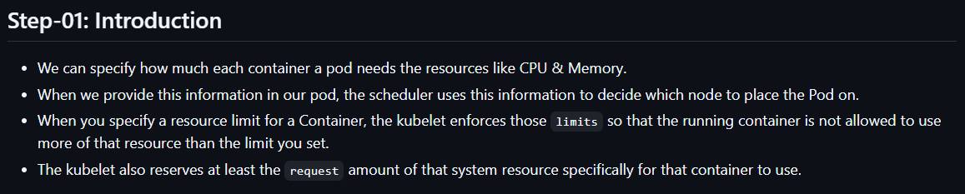
After adding the resources and limits value in our script like below
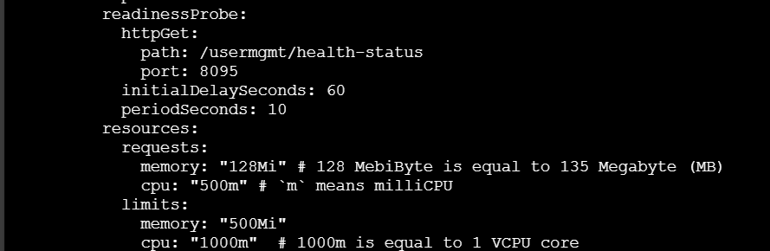
Save the file and run kubectl apply command. Once the pod is up run “kubectl describe node <Node-Name> “ command.
You can see the list of PODS running on the node with different namespaces.
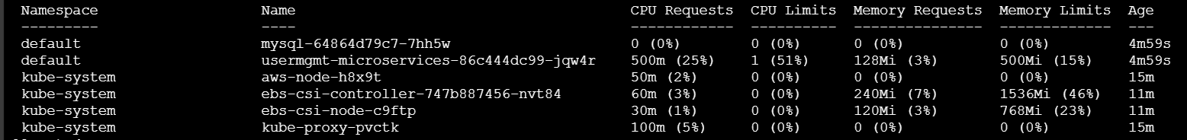
More about resources and limits verify this official doc Resource Management for Pods and Containers | Kubernetes .

Namespaces :-
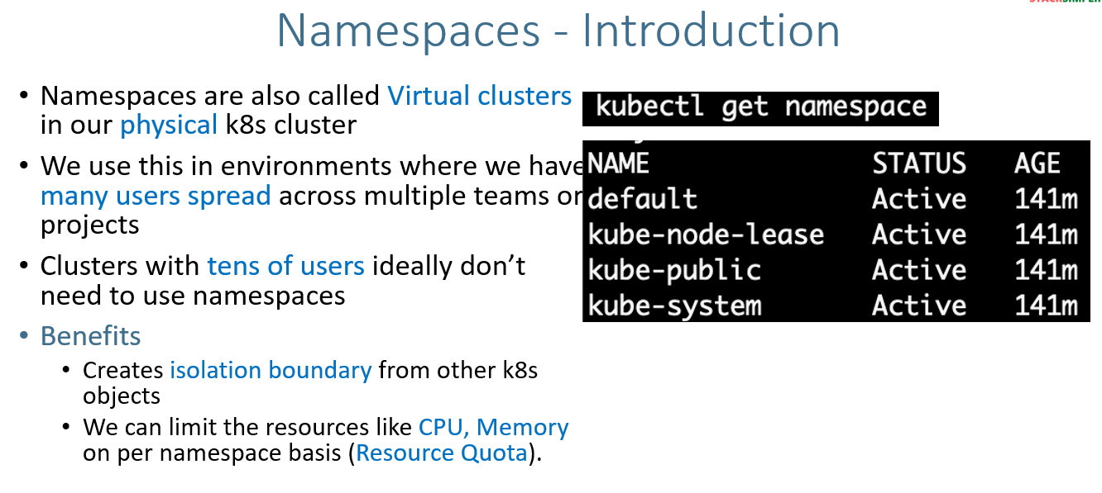
Imperative way:-
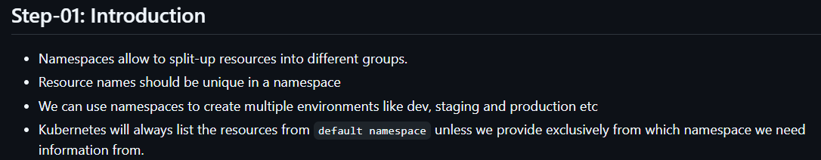
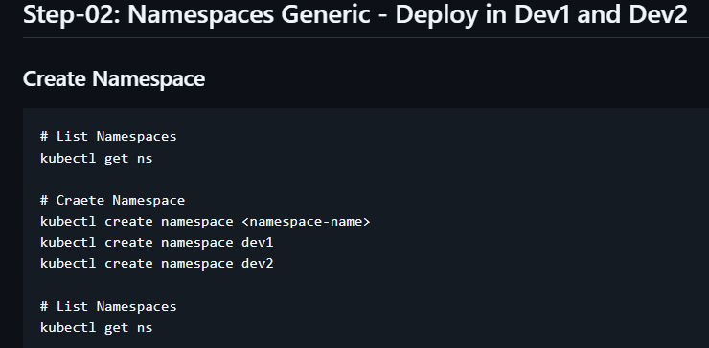
I have created the NS like below.
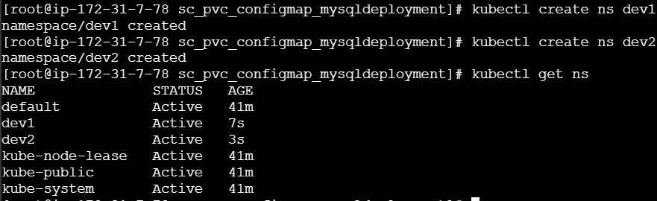
Now,
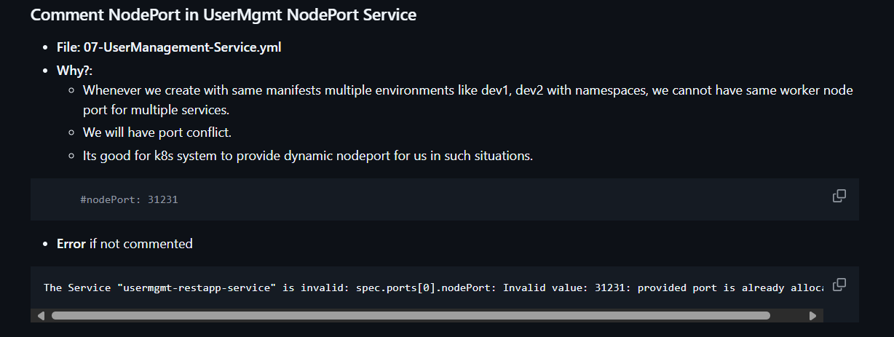
Now, let’s create usermanagement service and mysql service in dev1 & dev2 NS.
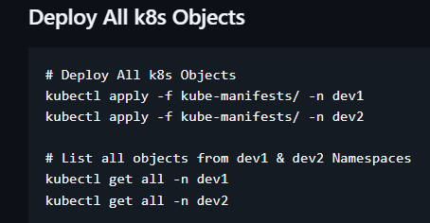
To list the PODS
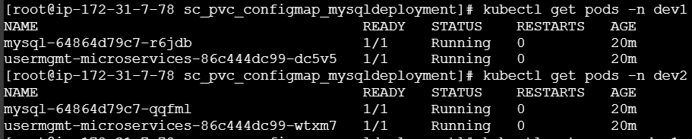
To list the SVC and PVC
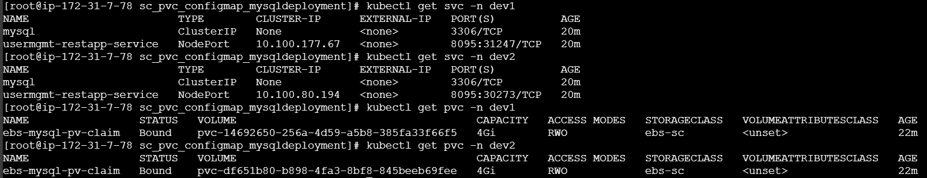
But SC, PV are not NS level they are generic you can see below:
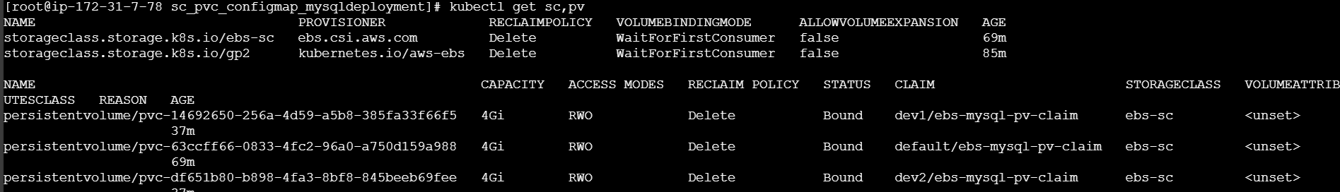
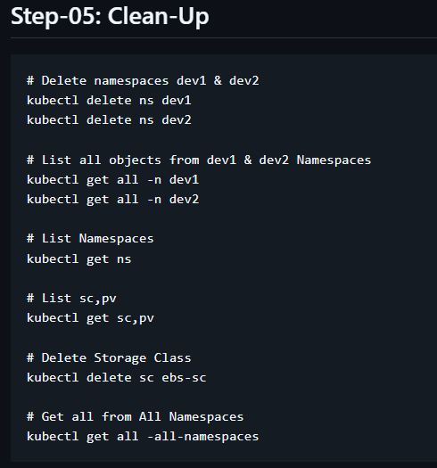
More about namespace in Namespaces Walkthrough | Kubernetes .
Limit Range:-
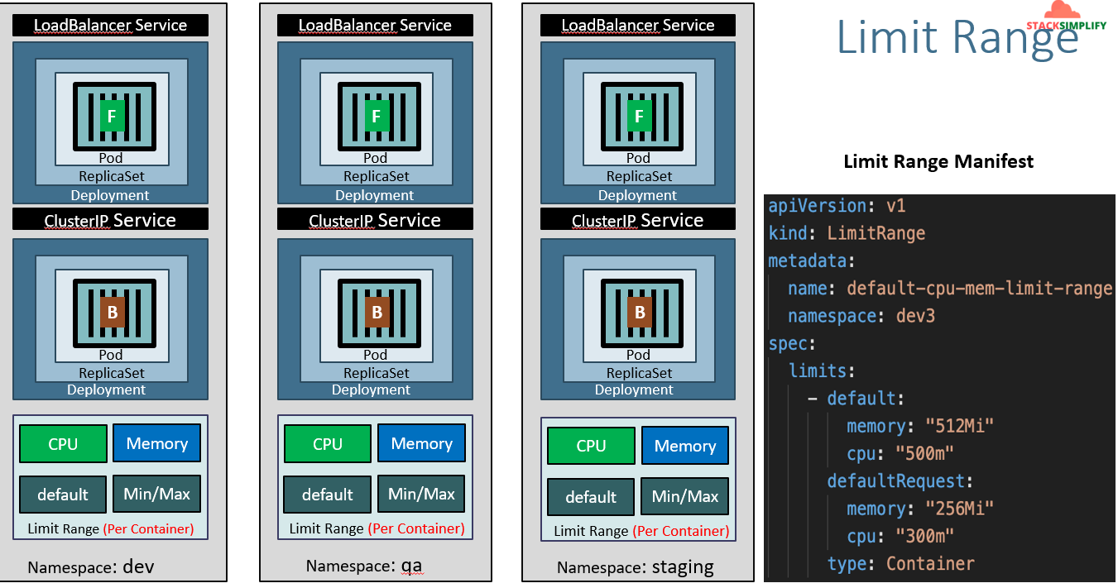
It’s used to define default value CPU & Memory either for whole NS. It create the containers inside the POD with default values.
Remember while you are running the declarative scripts always the NS script should be the first because while running kubectl apply the scripts will execute in alphabetic order. So, First we need to create the NS and rest are next.
Note:- If you don’t define the values while using LimitRange. The default cpu value is 1vcpu and for memory it will be 512Mi.
If you don’t define ‘defaultRequest’ values then pods will take ‘default’ values
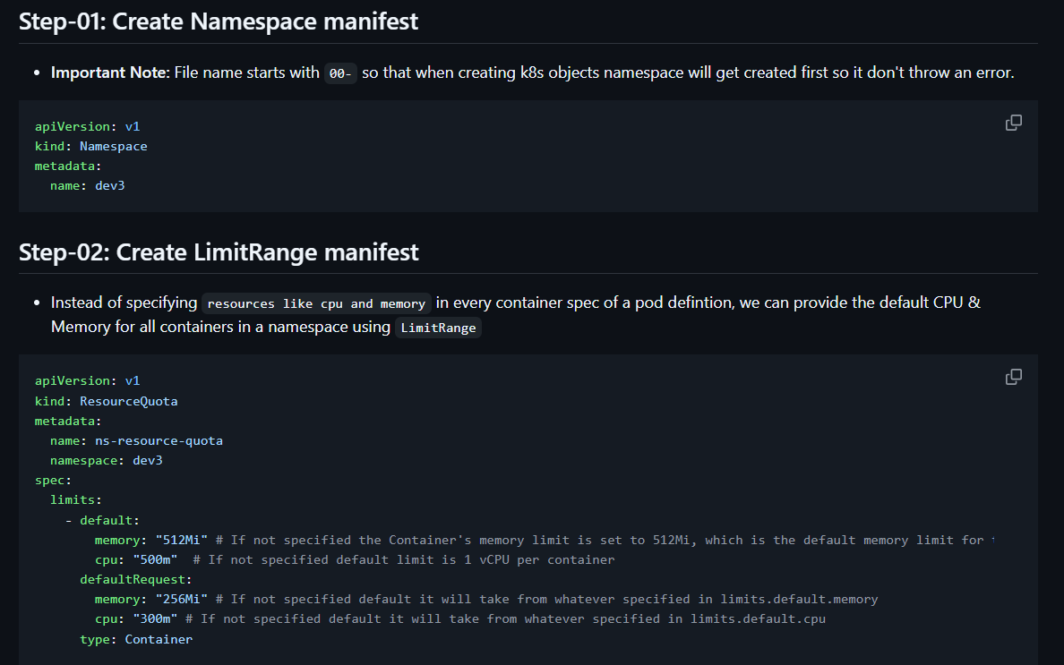
My script will look like below. I have defined both scripts in single file like below.
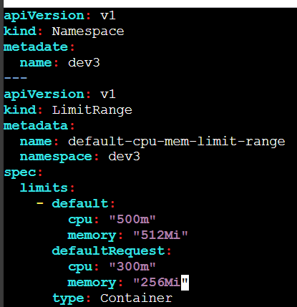
Now update ‘namespace: dev3’ in all metadata session in all the manifests except in ‘StorageClass’.
After apply command you can see the init container, App pod & mysql pod are having default and defaultvalues as limits and requests like below.
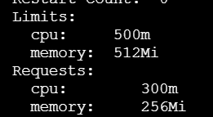
To see above values run ‘kubectl get pod <pod-name> -o yaml -n dev3’.
To get and describe the limits.
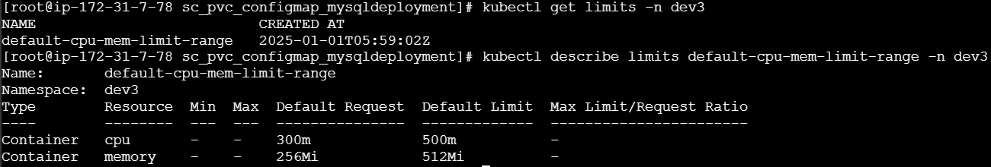
More about namespace in Namespaces Walkthrough | Kubernetes
More about configuring default CPU in Configure Default CPU Requests and Limits for a Namespace | Kubernetes
More about configuring default memory is in Configure Default Memory Requests and Limits for a Namespace | Kubernetes
Resource Quota:-
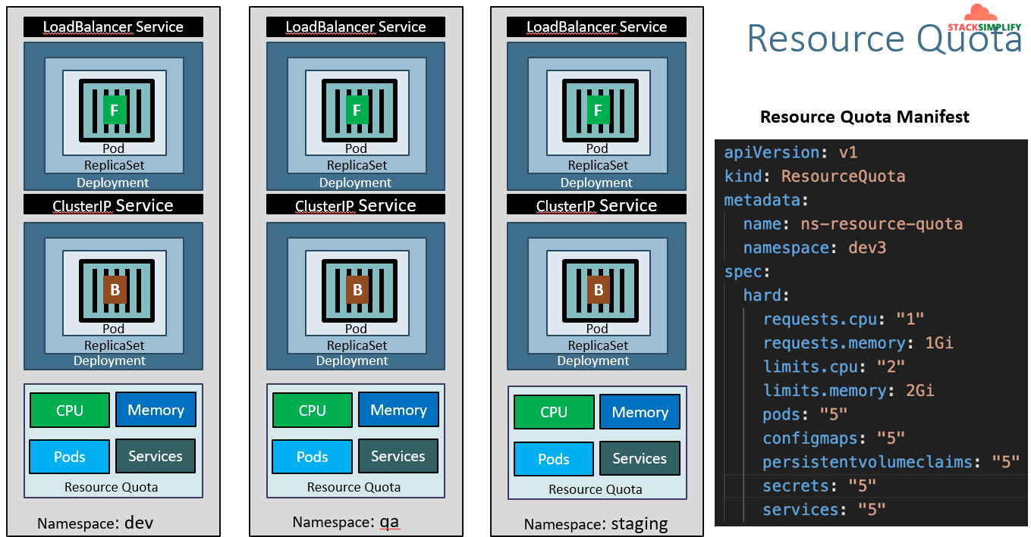
It’s used to limit the resources to particular count.
Eg: if you want to limit the number of PODS in a namespace to 5 by using resource quota we can do that. You can see the script in above SS.
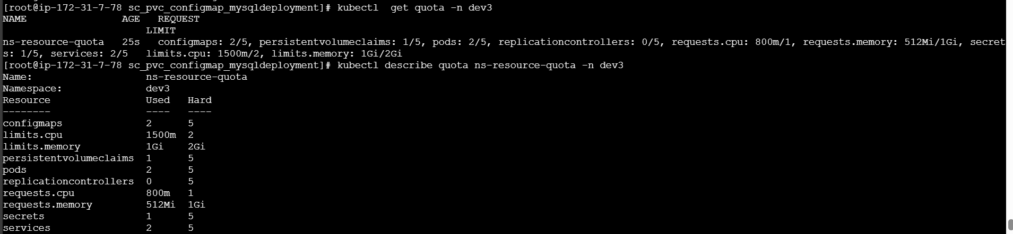
You can see in above SS how many resources got created after applying the resource quota
You can play it by increasing number of PODs and again you can see the count.

